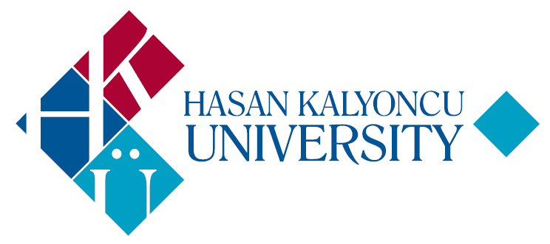 | HASAN KALYONCU UNIVERSITY  Faculty of Engineering  Course Description Form

COURSE: Geology for Civil Engineers
CODE: CE162 | SEMESTER: SPRING
LANGUAGE: ENGLISH | TYPE: COMPULSORY
PRE-REQUISITES: -  CO-REQUISITES: - | THEORY | PRACTICAL | CREDIT | ECTS
WEEKLY HOURS: 2 | 2 | 0 | 2 | 2

CONTENT OF THE COURSE:
Structure of the Earth, geological cycles, rock and mineral types, soil properties, geological structures, active tectonics and earthquake hazards, groundwater, dams and reservoirs, foundations, tunnels, slope stability and landslides, natural construction materials, formation and prevention of the natural disasters such as earthquake, flood, landslide, and avalanche

OBJECTIVE OF THE COURSE:
To introduce the basic knowledge of the layers of the earth, rocks and minerals, external and internal earth processes Better understanding of earthquake, flood, landslide etc. and precautions to be taken To develop students’ ability to visualize three dimensional nature of the geological units

WEEKLY SCHEDULE
Week | Topics
1 | Content and purpose of the course and basic terminology in geology
2 | Structure of the Earth, geological cycles , minerals and rocks
3 | Igneous rocks
4 | Sedimentary and metamorphic rocks
5 | Geological structures
6 | Hydrogeology
7 | Mass movements
8 | Midterm Week
9 | Foundation geology
10 | Geology of dam site
11 | Tunnel geology
12 | Earthquake
13 | Geological construction materials
14 | An overview

TEXTBOOK: •Lecture Notes, Engineering Geology by Perry H.Rahn Course web-site- Lecture Notes

EVALUATION SYSTEM:
IN-TERM STUDIES | QUANTITY | PERCENTAGE (%)
Midterm Exam | 1 | 40
Homework | -
Laboratory works | -
Quiz | -
Final Exam | 1 | 60
TOTAL | 2 | 100
CONTRIBUTION OF INTERM STUDIES TO OVERALL GRADE | 1 | 40
CONTRIBUTION OF FINAL EXAMINATION TO OVERALL GRADE | 1 | 60
TOTAL | 2 | 100

COURSE CATEGORY: | PERCENTAGE (%)
Mathematics and Basic Sciences | %20
Engineering | %50
Engineering Design | %30
Social Sciences | -

TABLE OF ECTS / WORKLOAD:
Activities | QUANTITY | Duration  (Hour) | Total  Workload
Course Duration | 13 | 2 | 26
Hours for off-the-classroom study (Pre-study, practice) | 14 | 2 | 28
Laboratory works | - | - | -
Mid-term | 1 | 2 | 2
Final examination | 1 | 2 | 2
Homework | - | - | -
Quiz | - | - | -
Total Work Load |  |  | 58
Total Work Load / 30 |  |  | 1,9
ECTS Credit of the Course |  |  | 2

 | PO1 | PO2 | PO3 | PO4 | PO5 | PO6 | PO7 | PO8 | PO9 | PO10 | PO11
LO1 | 1 | 0 | 0 | 0 | 0 | 0 | 0 | 0 | 0 | 0 | 0
LO2 | 1 | 0 | 0 | 0 | 0 | 0 | 0 | 0 | 0 | 0 | 0
LO3 | 1 | 0 | 3 | 0 | 3 | 0 | 0 | 0 | 0 | 0 | 0
LO4 | 1 | 0 | 3 | 0 | 3 | 0 | 0 | 0 | 0 | 0 | 0
LO5 | 1 | 0 | 3 | 0 | 3 | 0 | 0 | 0 | 0 | 0 | 0
PO: Program Outcomes | LO: Learning Outcomes
Values: 0: None | 1: Low | 2: Medium | 3: High

INSTRUCTOR(S): | Inst.Nurullah AKBULUT
FORM PREPARATION DATE: | 22.05.2019

LEARNING OUTCOMES OF THE COURSE: | PROGRAM OUTCOMES:
LO1: To define the basic types of earth materials, earth structures and earth processes  LO2: Occurrence and types of mass movements  LO3: Selection and investigation of dam site and reservoir area  LO4: Geology of foundation and tunnel  LO5: Natural construction materials | PO1: Adequate knowledge in mathematics, science and engineering subjects pertaining to the relevant discipline; ability to use theoretical and applied knowledge in these areas in complex engineering problems.  PO2: Ability to identify, formulate, and solve complex engineering problems; ability to select and apply proper analysis and modeling methods for this purpose.  PO3: Ability to design a complex system, process, device or product under realistic constraints and conditions, in such a way as to meet the desired result; ability to apply modern design methods for this purpose.  PO4: Ability to devise, select, and use modern techniques and tools needed for analyzing and solving complex problems encountered in engineering practice; ability to employ information technologies effectively.  PO5: Ability to design and conduct experiments, gather data, analyze and interpret results for investigating complex engineering problems or discipline specific research questions.  PO6: Ability to work efficiently in intra-disciplinary and multi-disciplinary teams; ability to work individually.  PO7: Ability to communicate effectively in Turkish, both orally and in writing; knowledge of a minimum of one foreign language; ability to write effective reports and comprehend written reports, prepare design and production reports, make effective presentations, and give and receive clear and intelligible instructions.  PO8: Recognition of the need for lifelong learning; ability to access information, to follow developments in science and technology, and to continue to educate him/herself.  PO9: Consciousness to behave according to ethical principles and professional and ethical responsibility; knowledge on standards used in engineering practice.  PO10: Knowledge about business life practices such as project management, risk management, and change management; awareness in entrepreneurship, innovation; knowledge about sustainable development.  PO11: Knowledge about the global and social effects of engineering practices on health, environment, and safety, and contemporary issues of the century reflected into the field of engineering; awareness of the legal consequences of engineering solutions.

